1. Postman Screenshot of creating a new role called ‘Reader’ in the application.

Application URL:- localhost:8080/role/save

PostMan Screen Shot:-

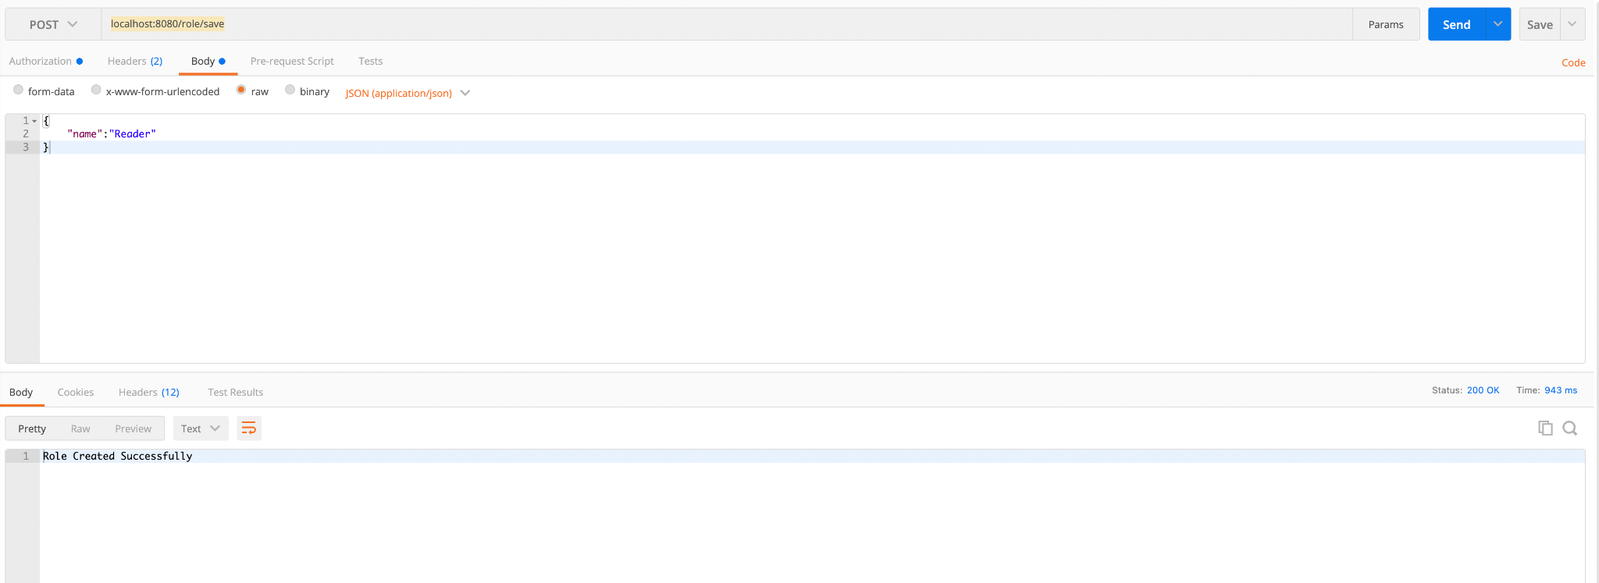

H2 Database Screen shot:-

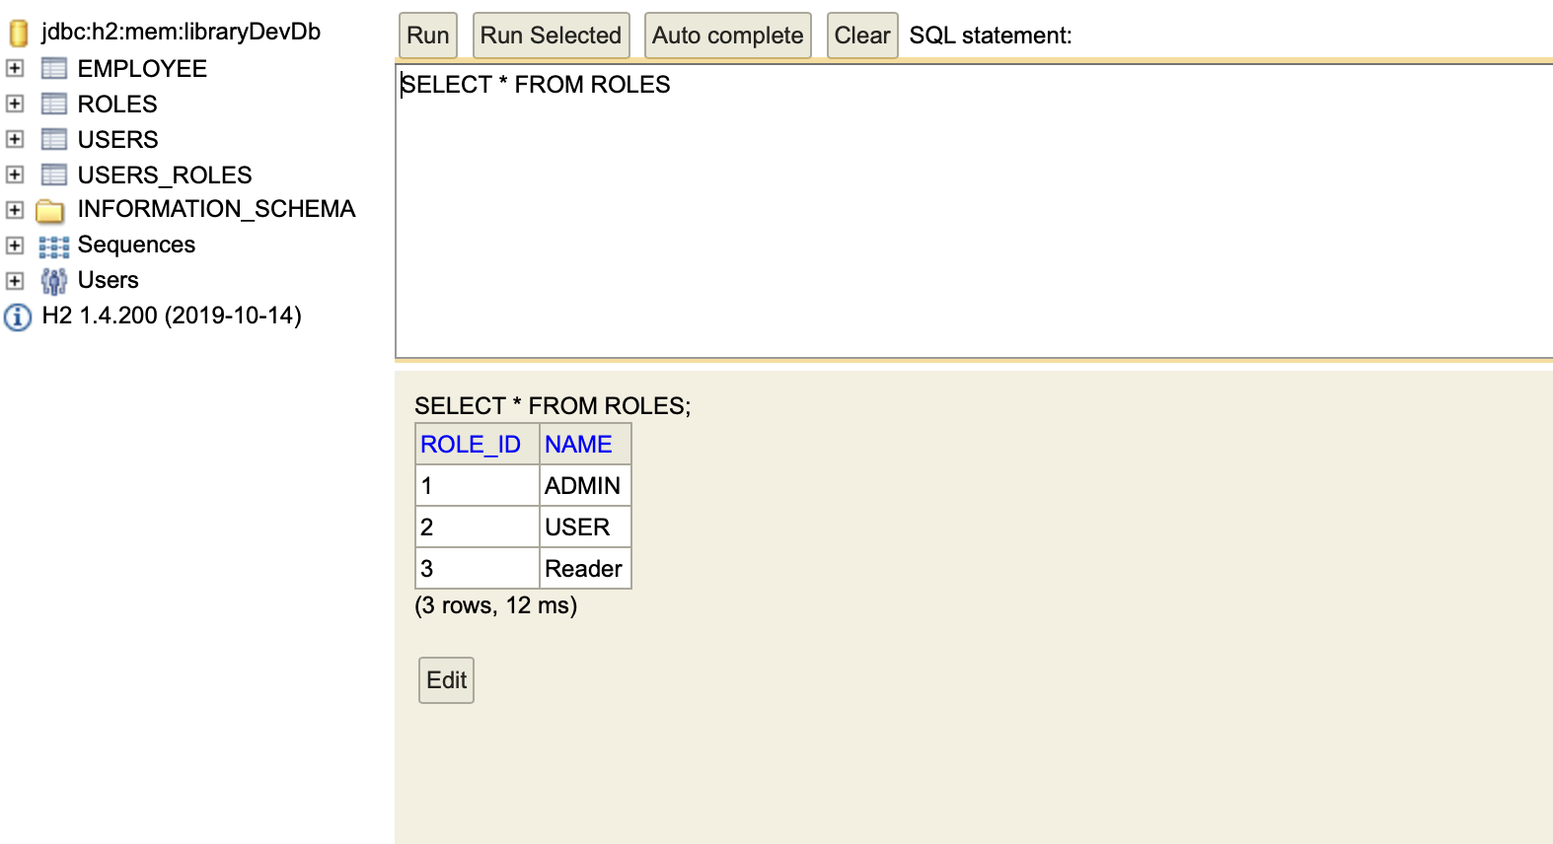

1. Create a new User in the Application:-

Application URL:- localhost:8080/user/save

PostMan Screen Shot:-

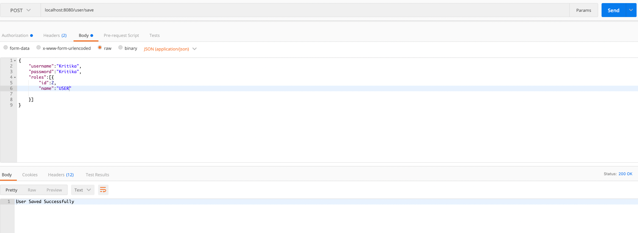

H2 Database Screen shot:-

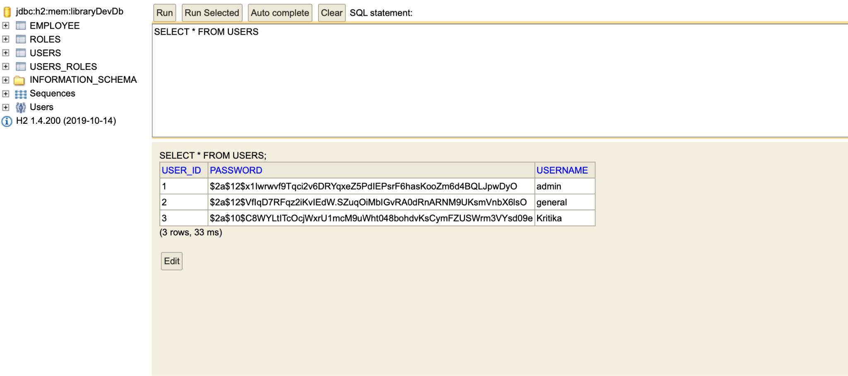

1. Adding an Employee in the Database with the Admin User:-

Application URL:- localhost:8080/employee/add

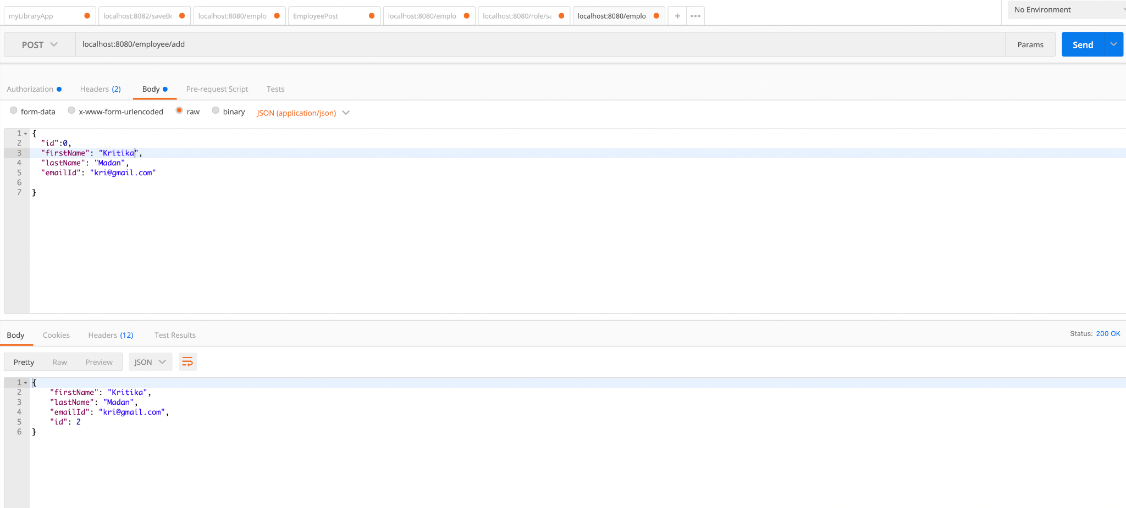

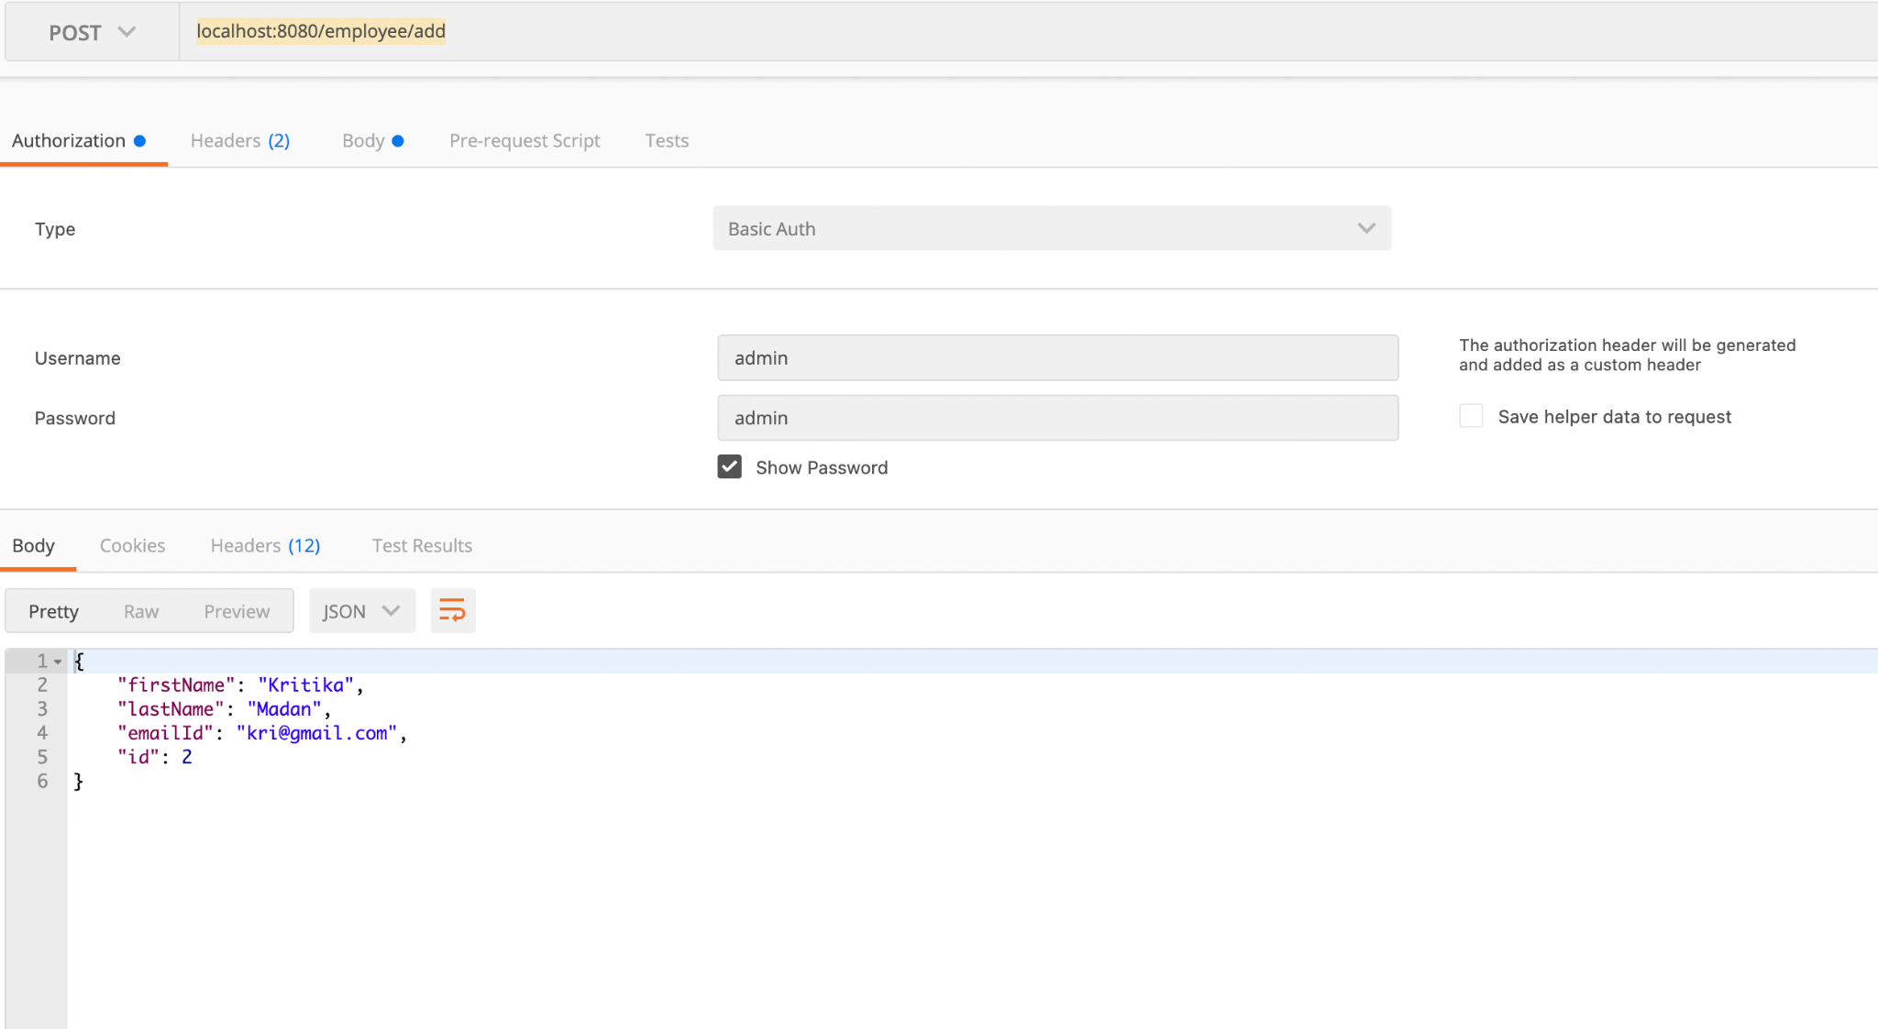

H2- Database Screen Shot

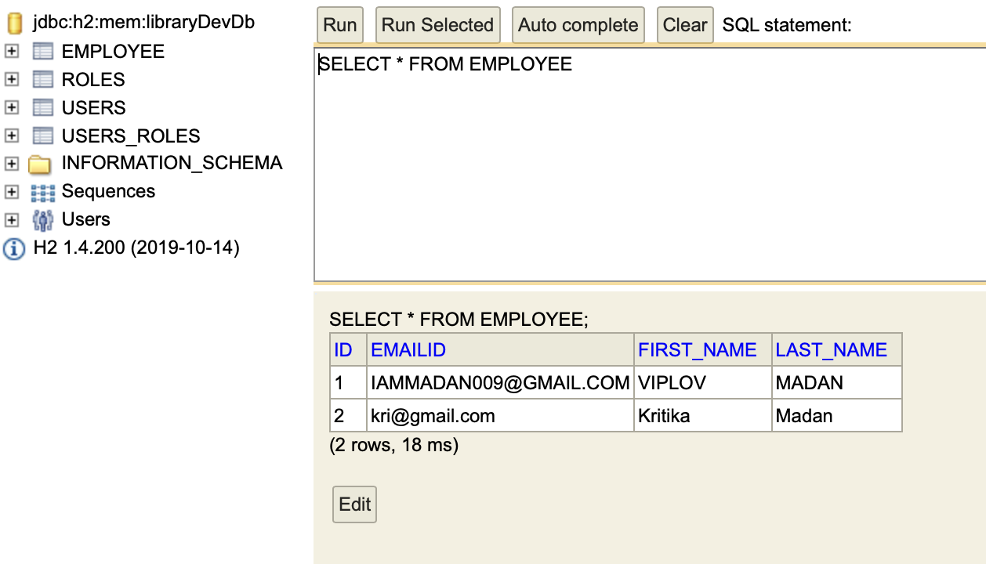

Screen shot to Prove not being able to add an ID with a user called general who does not have ADMIN role:-

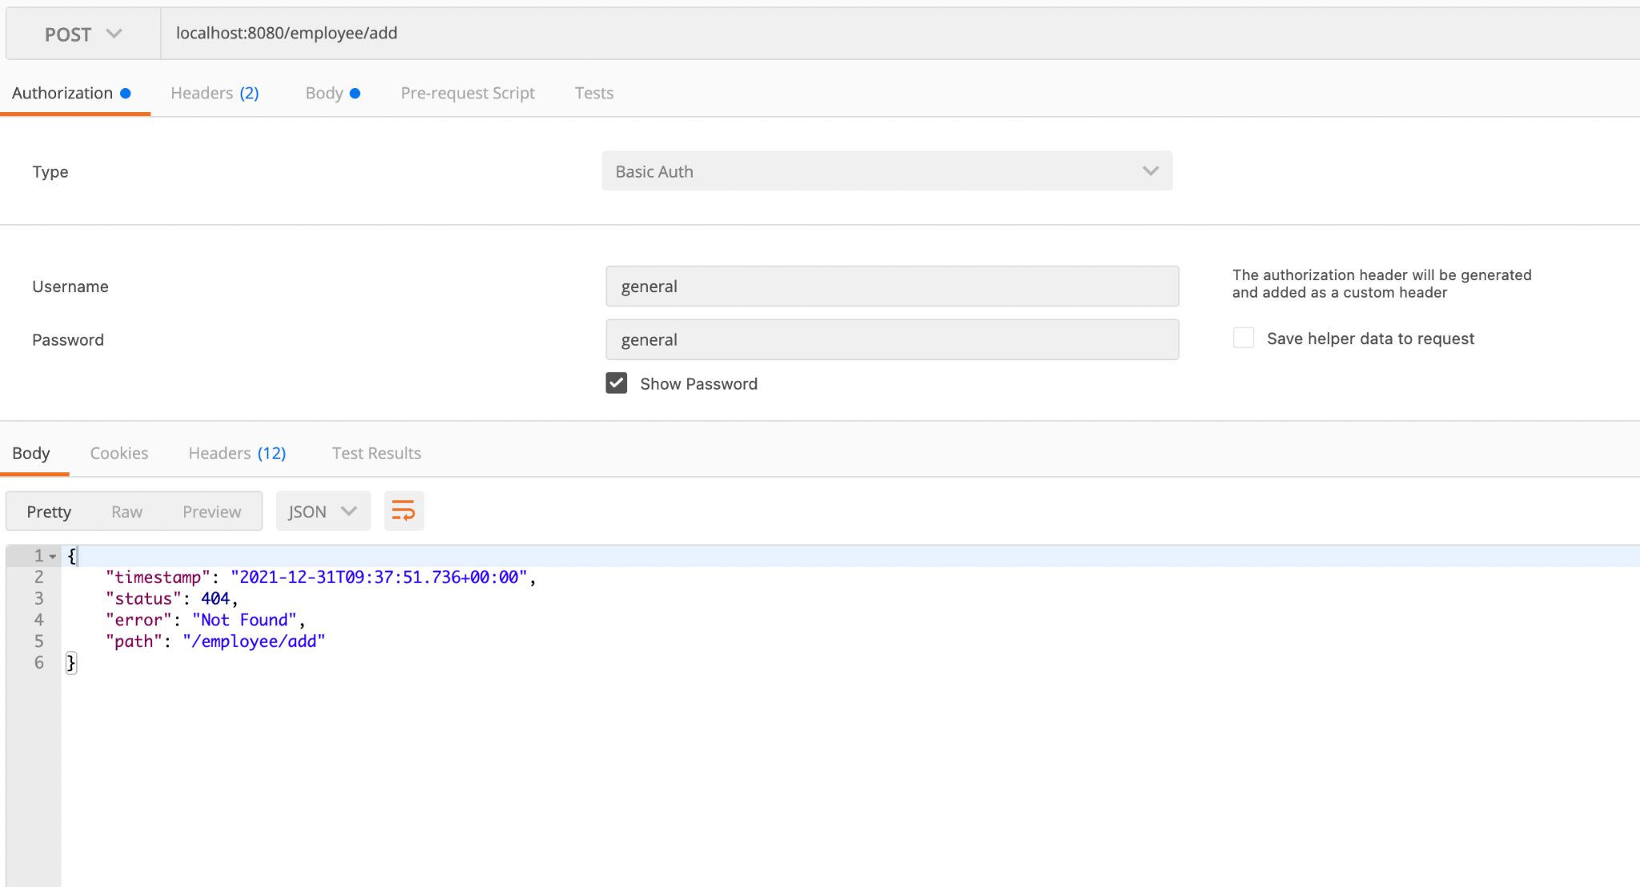

1. Endpoint to List All Employees in the Database:-

Application URL:- localhost:8080/employee/list

PostMan Screen Shot:-

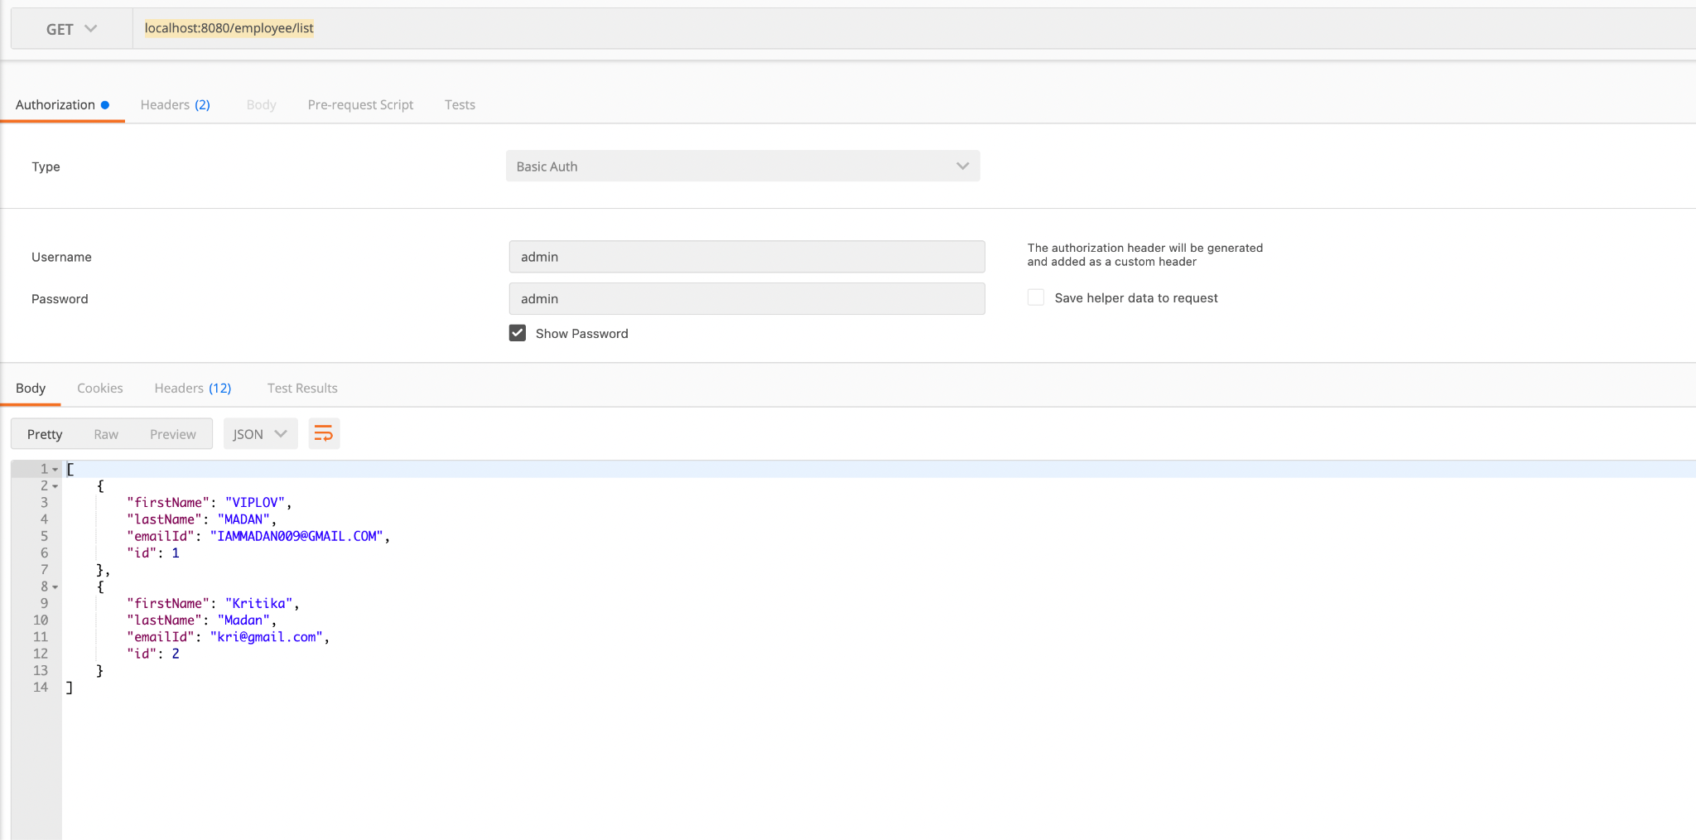

1. Fetch Employee based on an ID:-

Application URL:- localhost:8080/employee/listById/2

PostMan Screen Shot:-

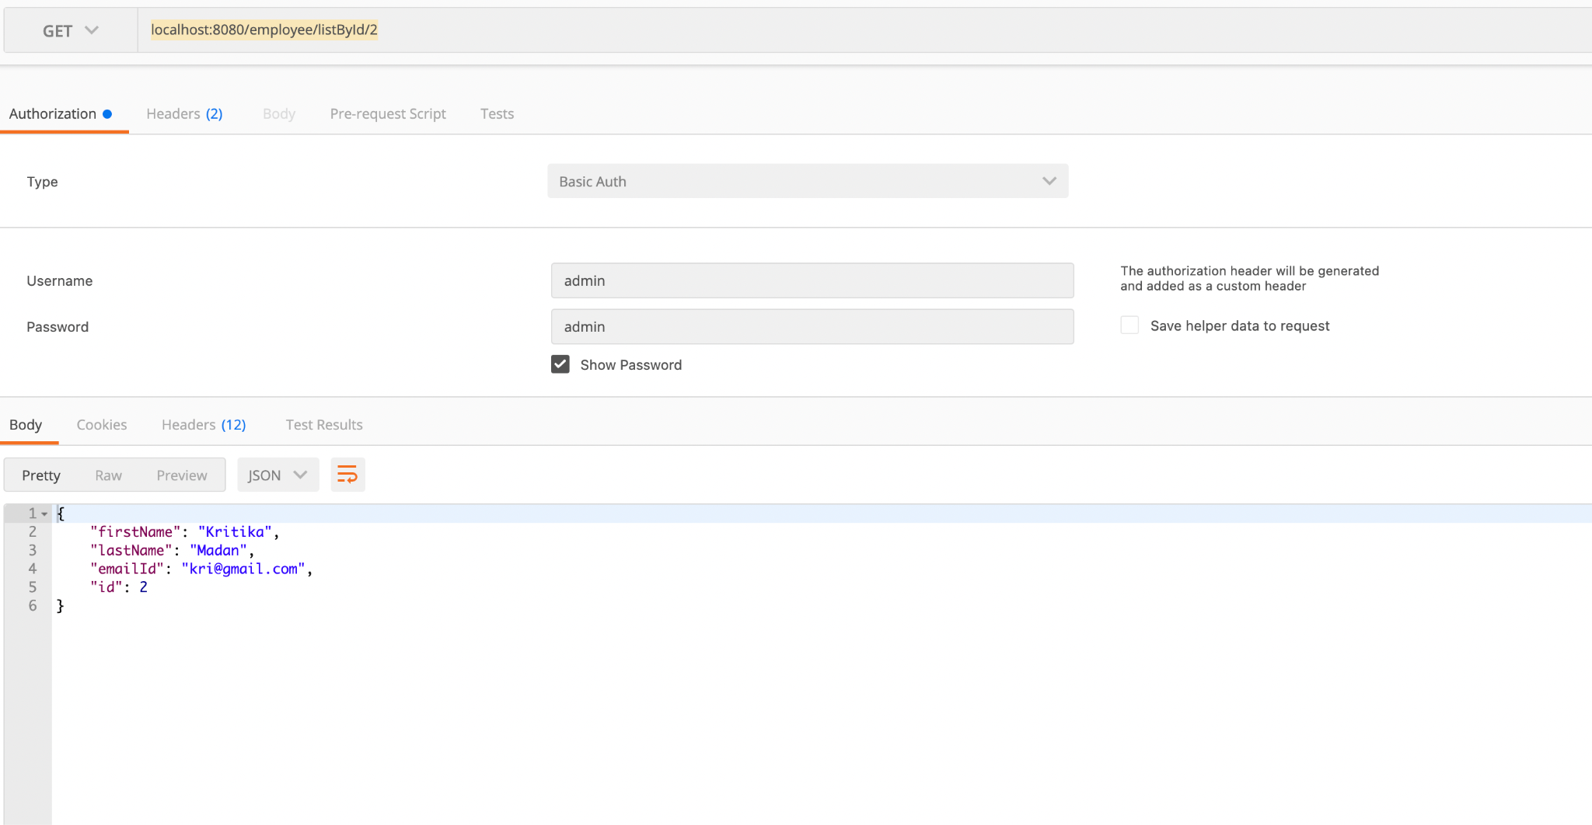

1. Endpoint to Update and Existing Employee:-

Application URL:- localhost:8080/employee/add

PostMan Screen Shot:-

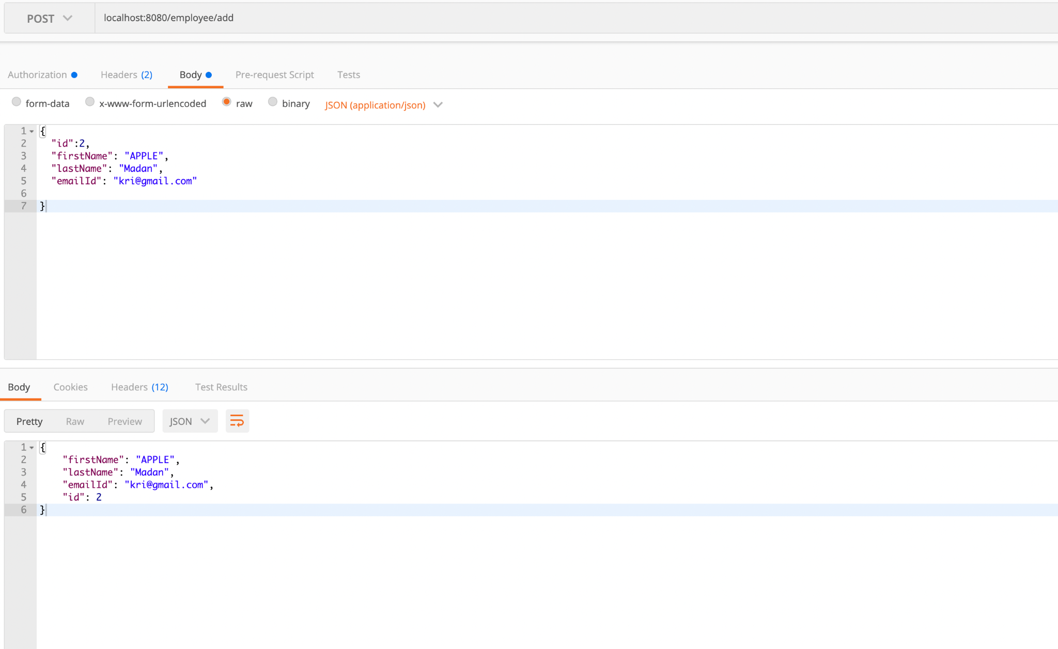

H2-Database Screen Shot:-

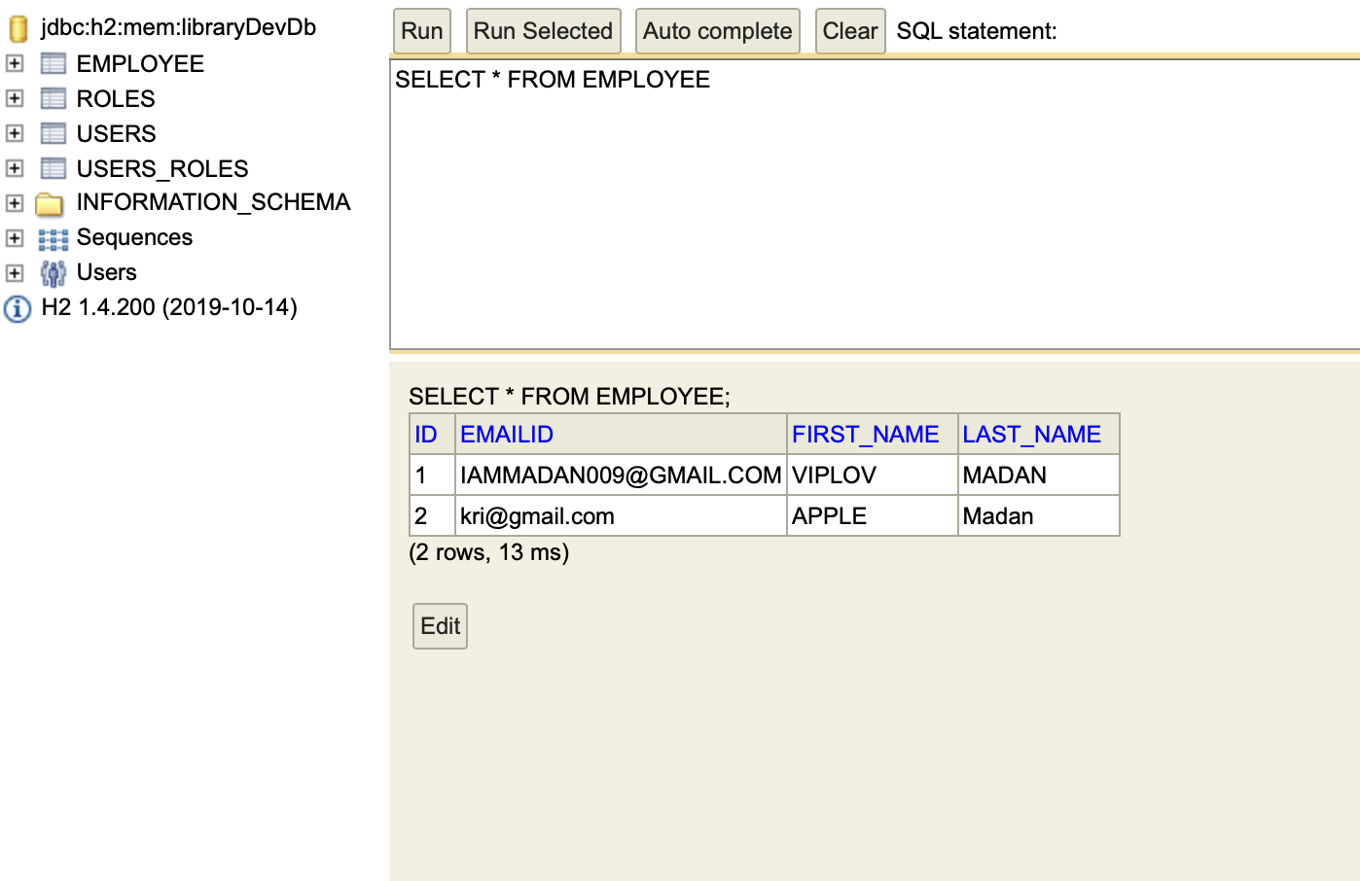

1. Delete an Employee based on the ID:-

Application URL:- localhost:8080/employee/deleteById/2

Postman Screen Shot:-

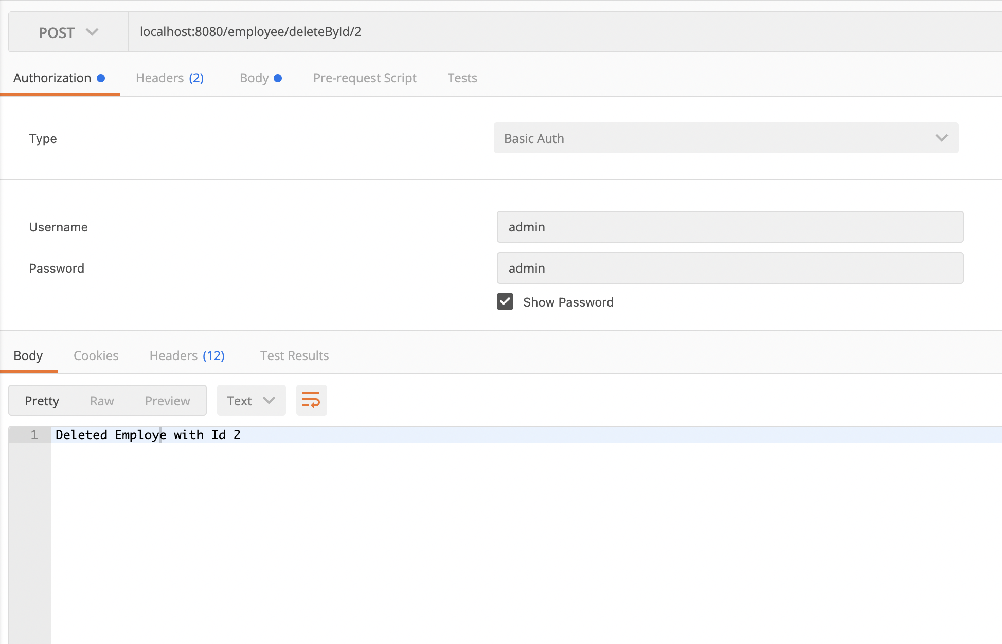

H2 Database Screen Shot after Employee with ID2 has been deleted:-

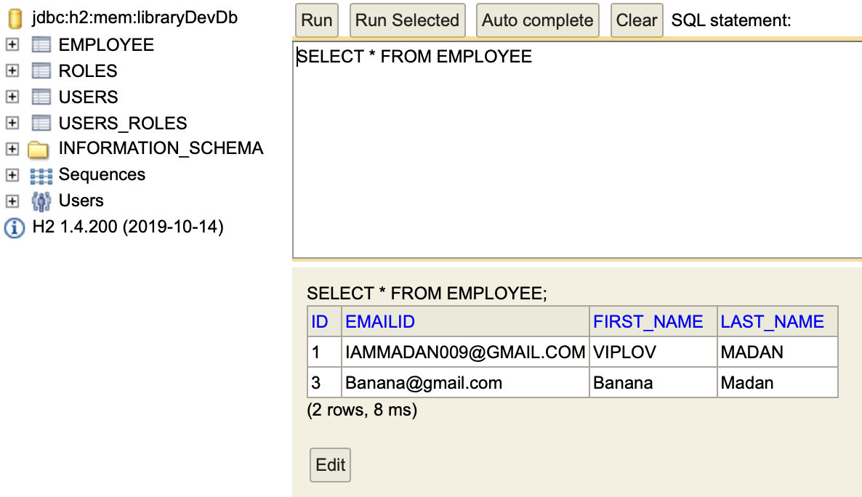

1. Search an Employee by First Name and return all in case more than 1 exist

Application URL:- localhost:8080/employee/findByName/viplov

PostMan Screen Shot:-

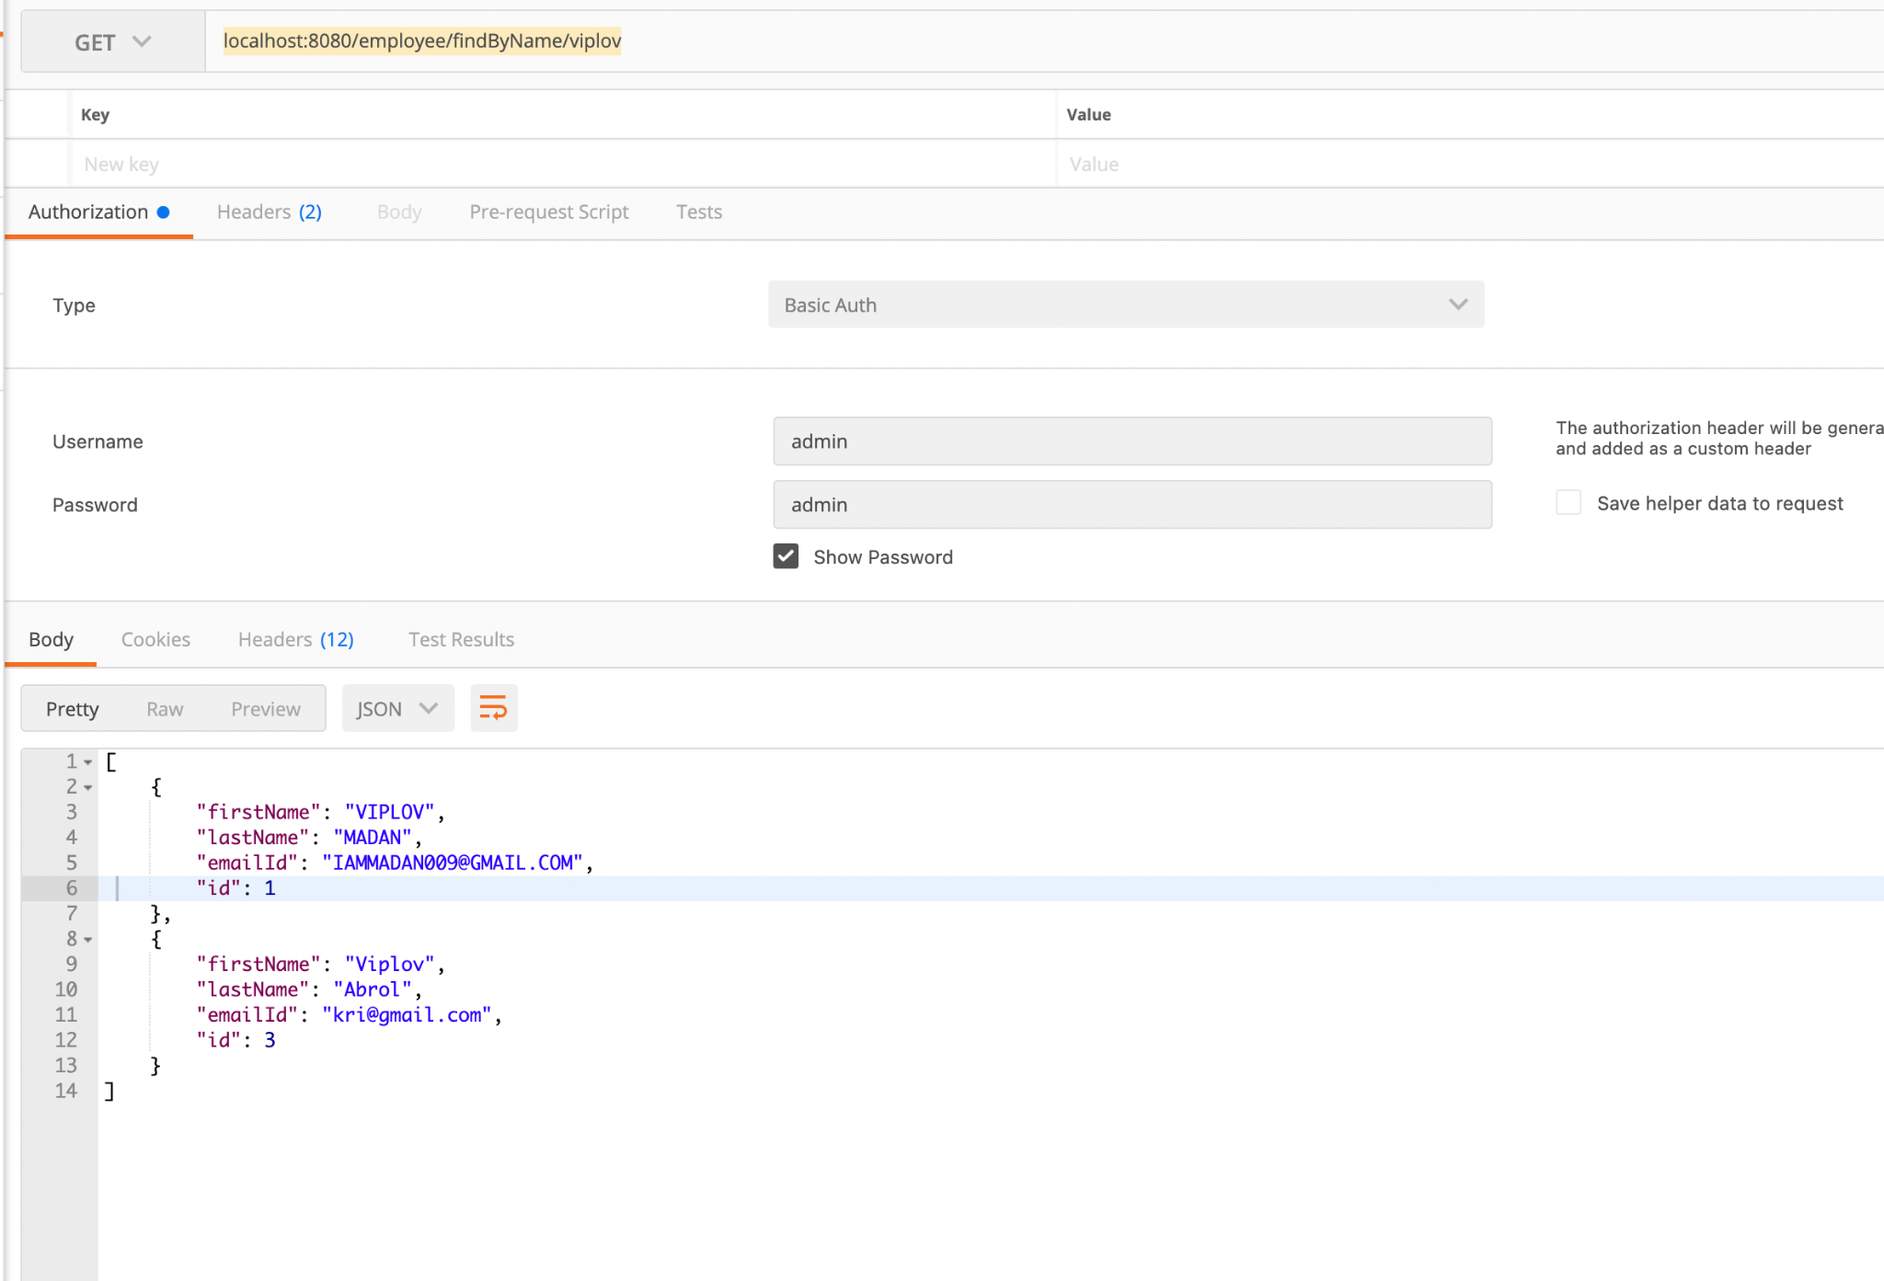

H2-Database Screen Shot:-

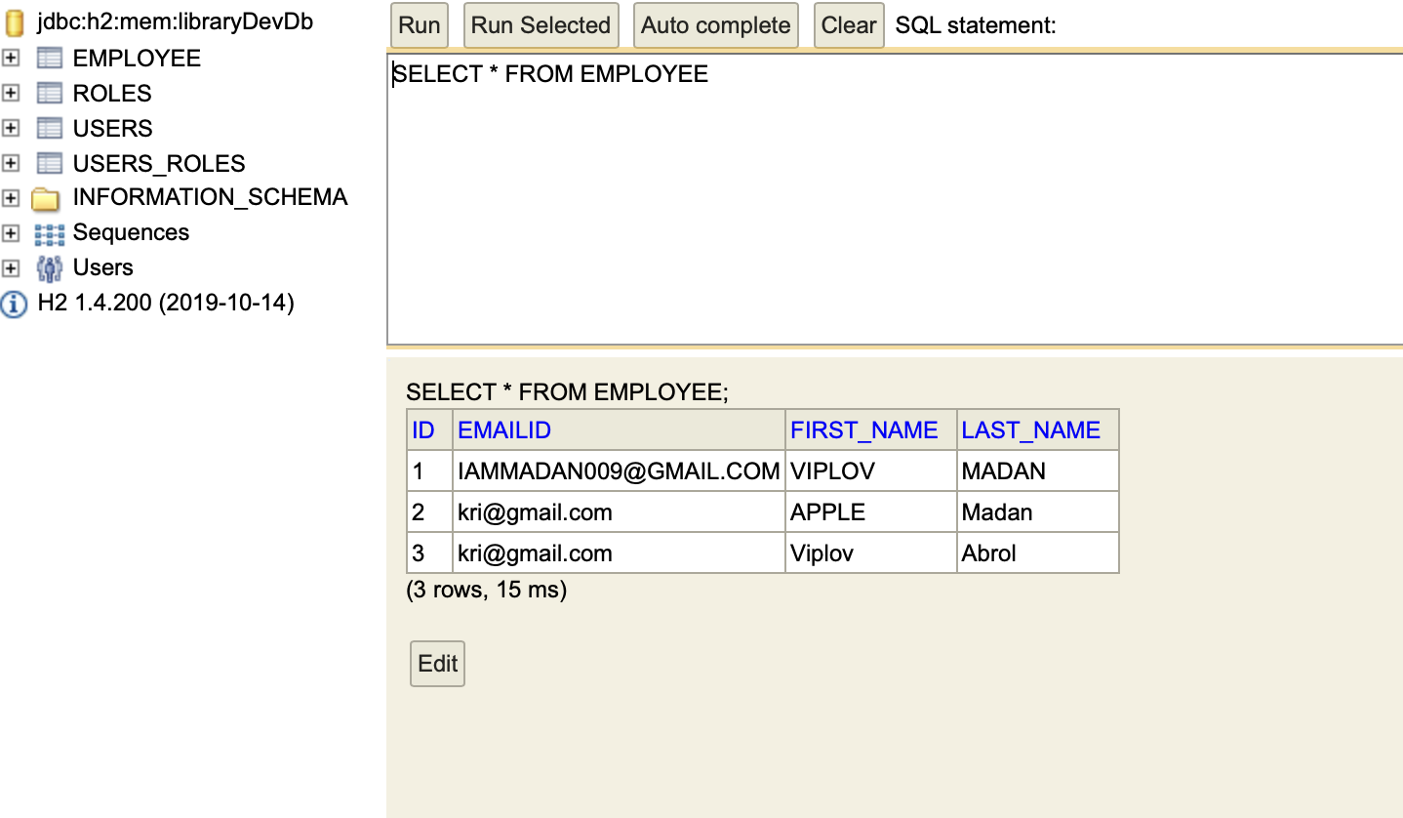

1. Sort Employee records in Ascending and Descending Order:-

Post Man screen shot for Ascending:-

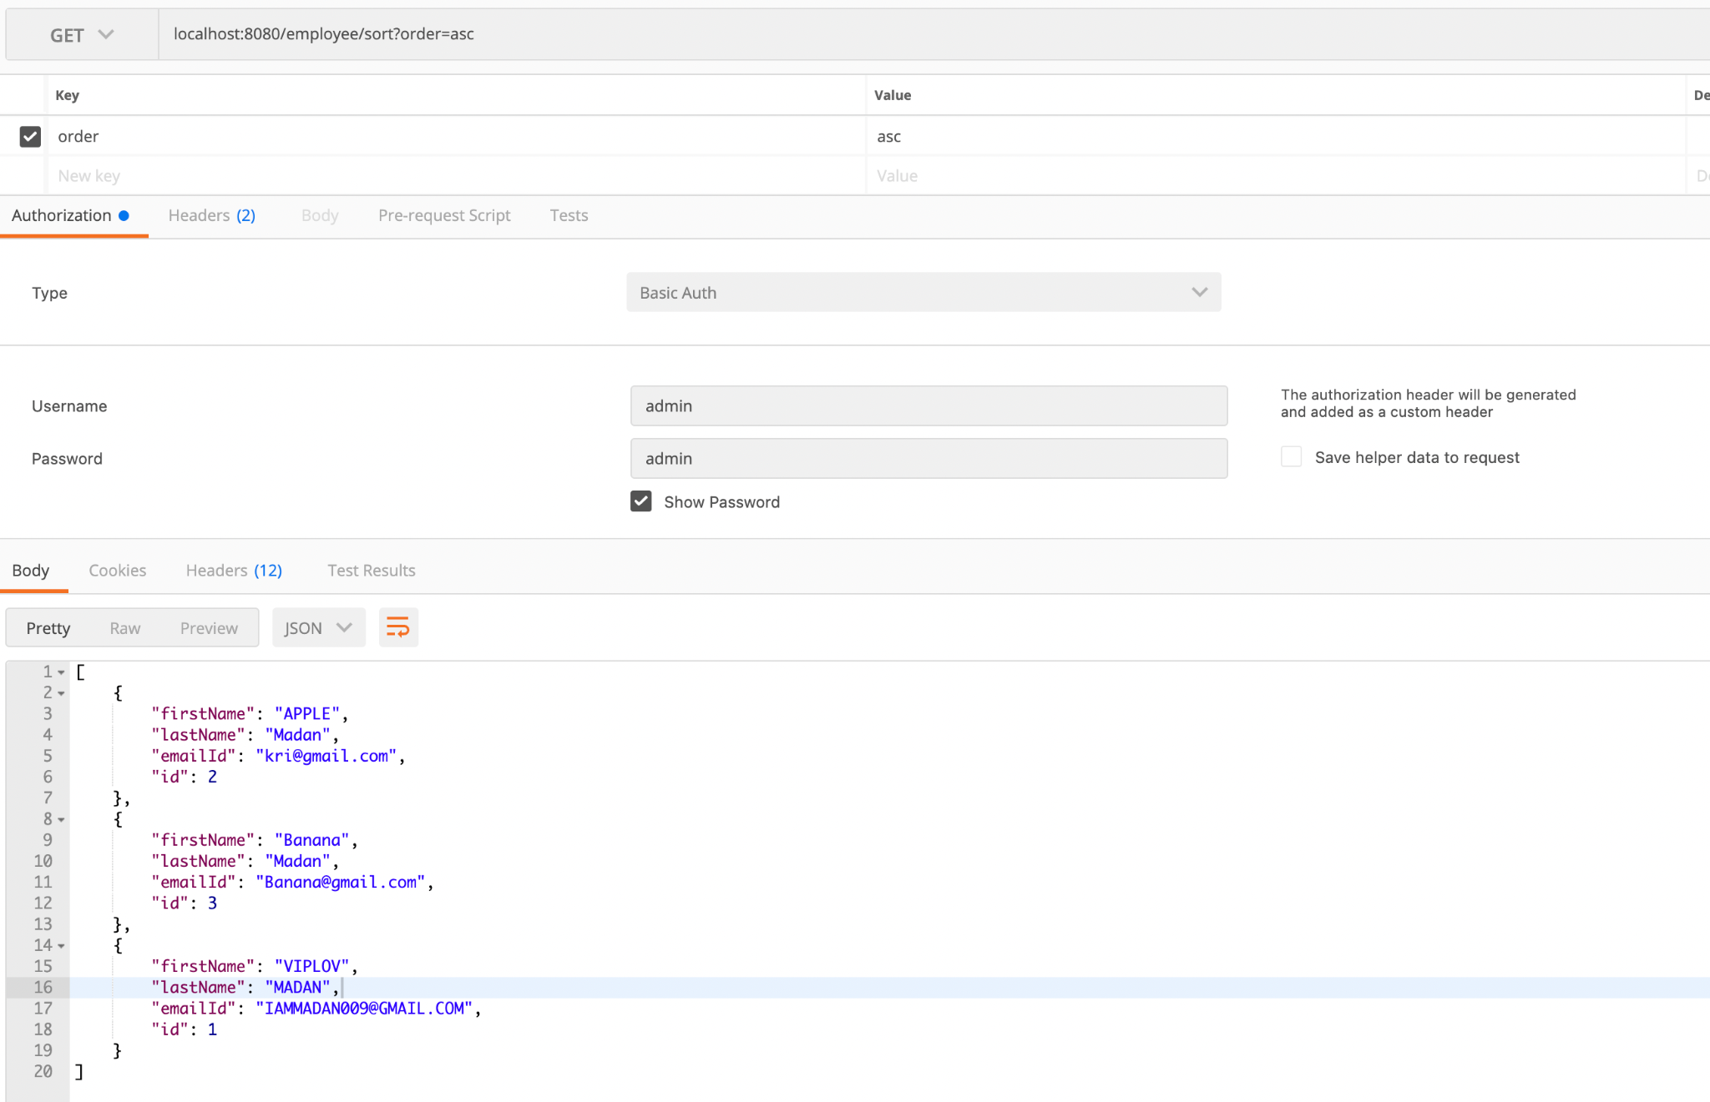

PostMan screen shot for Descending:-

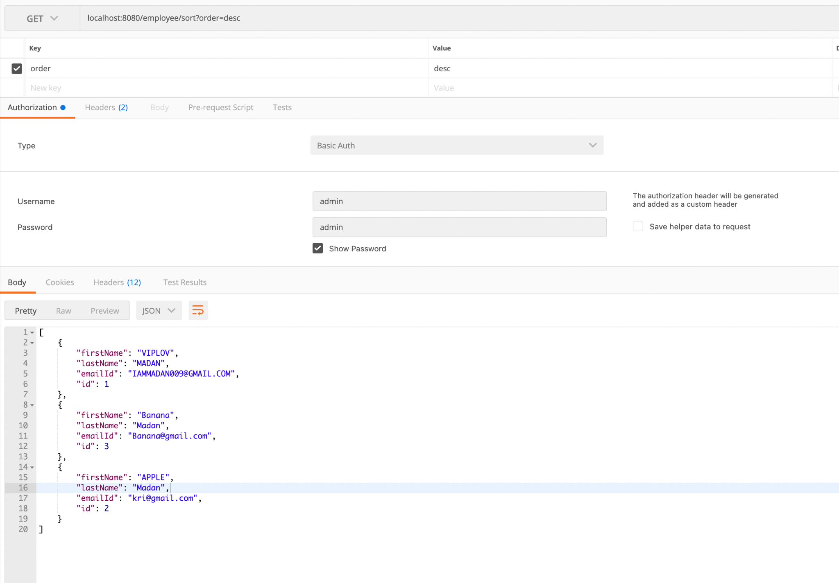

H2-Database Screen shot:-

